**A5516– CLOUD COMPUTING**

**UNIT I**

**Cloud Computing**

* The on-demand delivery of compute power, databases, storage, applications, and other IT resources using the internet with pay-as-you-go pricing.
* US National Institute of Standards and Technology defines Computing as :
* “ Cloud computing is a model for enabling ubiquitous, convenient, on-demand network access to a shared pool of configurable computing resources (e.g networks, servers, storage, applications, and services) that can be rapidly provisioned and released with minimal management effort or service provider interaction. ”

**Essential Characteristics**

* On-demand self-service

•A consumer can unilaterally provision computing capabilities, such as server time and network storage, as needed automatically without requiring human interaction with each service provider.

* Broad network access

•Capabilities are available over the network and accessed through standard mechanisms that promote use by heterogeneous thin or thick client platforms (e.g., mobile phones, tablets, laptops, and workstations).

* Resource pooling

-The provider’s computing resources are pooled to serve multiple consumers using a multi-tenant model, with different physical and virtual resources dynamically assigned and reassigned according to consumer demand.

* Measured Service

–Cloud systems automatically control and optimize resource use by leveraging a metering capability at some level of abstraction appropriate to the type of service (e.g., storage, processing, bandwidth, and active user accounts). Resource usage can be

–monitored, controlled, and reported, providing transparency for both the provider and consumer of the utilized service.

* Rapid elasticity

–Capabilities can be elastically provisioned and released, in some cases automatically, to scale rapidly outward and inward commensurate with demand. To the consumer, the capabilities available for provisioning often appear to be unlimited and can be appropriated in any quantity at any time.

**Advantages of Cloud Computing**

* Lower computer costs
* Improved performance
* Reduced software costs:
* Instant software updates
* Improved document format compatibility.
* Unlimited storage capacity
* Increased data reliability
* Universal information access
* Latest version availability
* Easier group collaboration
* Device independence

**Disadvantages of Cloud Computing**

* Requires a constant internet connection
* Does not work well with low-speed connections
* Features might be limited
* Can be slow
* Stored data might not be secured
* Stored data can be lost!
* High performance system
* General Concerns :Each cloud systems uses different protocols and different APIs

**Cloud Computing Applications**

* Storing File Online
* Video Making and Editing Software
* File Converters
* Anti-Virus Applications
* E-commerce Application
* Business Process
* Backup and Recovery
* Big Data Analysis
* Disaster Recovery

Computing paradigm

Cloud Computing in a Nutshell- Roots of Cloud

**Centralized Computing**

* The computing done using a single computer, which is not part of any network is referred to as monolithic computing.
* Since there is only one user who is using a system at a given instance of time therefore the computing is called a single user monolithic computing.
* multiple users can establish connections with this computer using a device known as "terminal", so as to enable interaction between the users during terminal session
* Computer resources like processor, memory are centralized in single m/c.

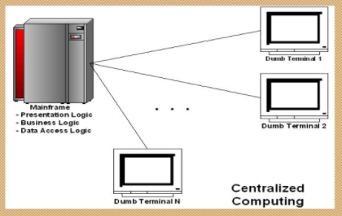

**Distributed Computing**

* Distributed computing is a model in which components of a software system are shared among multiple computers. Even though the components are spread out across multiple computers, they are run as one system. This is done in order to improve efficiency and performance.
* A distributed system can consist of any number of possible configurations, such as mainframes, personal computers, workstations, minicomputers, and so on. The goal of distributed computing is to make such a network work as a single computer.
* Ex: ATM, Intranets/Workgroups

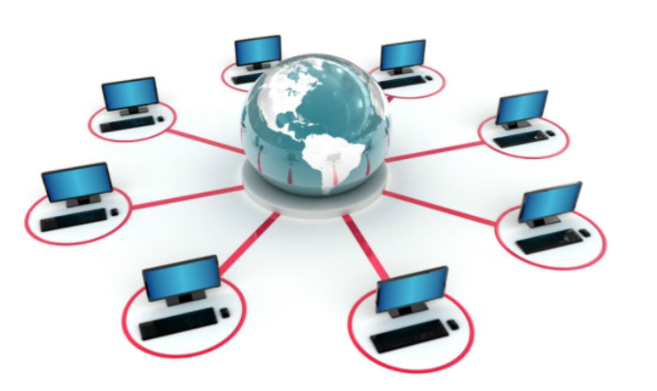

**Parallel Computing**

* Parallel computing refers to the process of breaking down larger problems into smaller, independent, often similar parts that can be executed simultaneously by multiple processors communicating via shared memory, the results of which are combined upon completion as part of an overall algorithm. The primary goal of parallel computing is to increase available computation power for faster application processing and problem solving.
* Parallel computing provides concurrency and saves time and money.

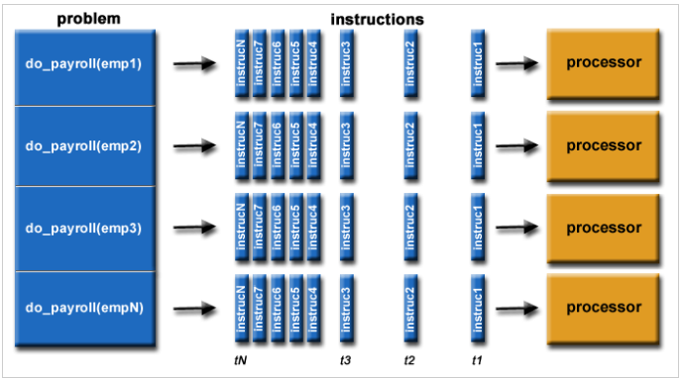

**Client -Server Computing**

* the client-server paradigm refers to a model for network applications where processes play one of two different roles: a server process, also called a server, is dedicated to managing access to some resources such as printers or files or a network service, while client processes, called clients, access the server to use these resources or network service to complete a task.
* A server process runs on a network-connected computer called as the server host, to manage a network service provided by that host. A client host makes use of a client process to access a particular service.

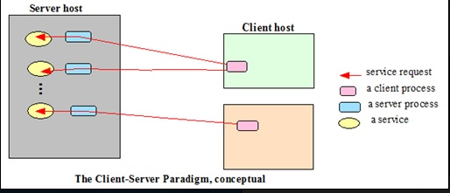**s**

**Ubiquitous Computing**

* Ubiquitous computing (or "ubicomp") is a concept in software engineering and computer science  where computing is made to appear anytime and everywhere. In contrast to desktop computing, [ubiquitous](https://en.wikipedia.org/wiki/Ubiquitous) computing can occur using any device, in any location, and in any format. A user interacts with the computer, which can exist in many different forms, including laptops computers ,tablets and terminals in everyday objects such as a [refrigerator](https://en.wikipedia.org/wiki/Refrigerator)
* IoT is supported by cloud to achieve ubiquitous computing with any object at anytime.

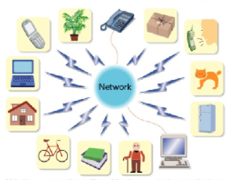

**Grid Computing**

* Grid computing is the use of widely distributed [computer](https://en.wikipedia.org/wiki/Computer) [resources](https://en.wikipedia.org/wiki/System_resource) to reach a common goal. A computing grid can be thought of as a [distributed system](https://en.wikipedia.org/wiki/Distributed_system) with non-interactive workloads that involve many files.
* single grid can be dedicated to a particular application
* Grid Computing is a subset of distributed computing, where a virtual super computer comprises of machines on a network connected by some bus, mostly Ethernet or sometimes the Internet. It can also be seen as a form of [Parallel Computing](https://www.geeksforgeeks.org/introduction-to-parallel-computing/) where instead of many CPU cores on a single machine, it contains multiple cores spread across various locations.

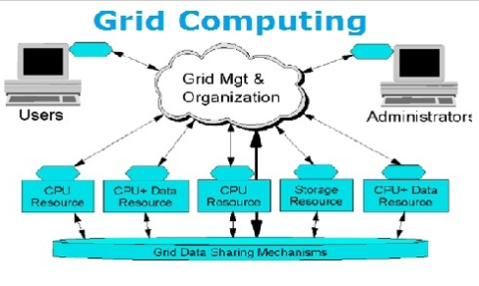

**Deployment Models(Types of cloud)**

* Public Cloud
* Private Cloud
* Hybrid Cloud
* Community Cloud

**Public Cloud**

* Cloud infrastructure is provisioned for open use by the general public. It may be owned, managed, and operated by a business, academic, or government organization, or some combination of them. It exists on the premises of the cloud provider.
* Examples of Public Cloud:
* Google App Engine
* Microsoft Windows Azure
* IBM Smart Cloud
* Amazon EC2

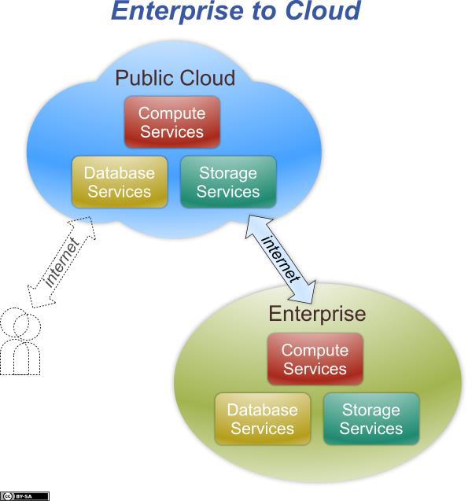

* In Public setting, the provider's computing and storage resources are potentially large; the communication links can be assumed to be implemented over the public Internet; and the cloud serves a diverse pool of clients (and possibly attackers).



**Private Cloud**

* The cloud infrastructure is provisioned for exclusive use by a single organization comprising multiple consumers (e.g., business units). It may be owned, managed, and operated by the organization, a third party, or some combination of them, and it may exist on or off premises.
* Examples of Private Cloud:

–Eucalyptus

–Ubuntu Enterprise Cloud - UEC

–Amazon VPC (Virtual Private Cloud)

–VMware Cloud Infrastructure Suite

–Microsoft ECI data center.

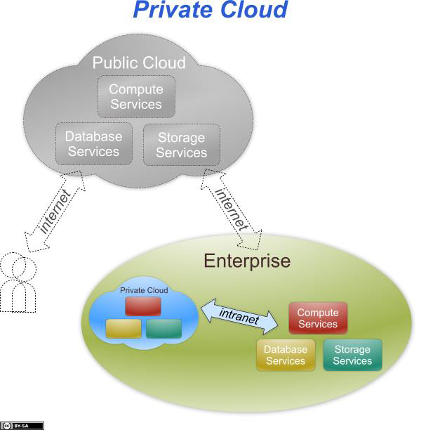

* Contrary to popular belief, private cloud may exist off premises and can be managed by a third party. Thus, two private cloud scenarios exist, as follows:

•On-site Private Cloud

–Applies to private clouds implemented at a customer’s premises.

•Outsourced Private Cloud

–Applies to private clouds where the server side is outsourced to a hosting company.

**On-site Private Cloud**

* The security perimeter extends around both the subscriber’s on-site resources and the private cloud’s resources.
* Security perimeter does not guarantees control over the private cloud’s resources but subscriber can exercise control over the resources.

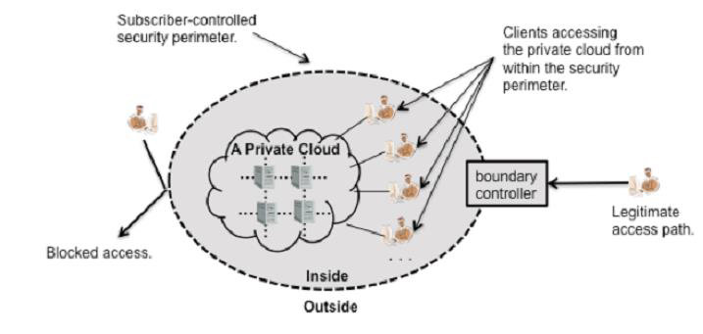

**Outsourced Private Cloud**

* Outsourced private cloud has two security perimeters, one implemented by a cloud subscriber (on the right) and one implemented by a provider.
* •Two security perimeters are joined by a protected communications link.
* •The security of data and processing conducted in the outsourced private cloud depends on the strength and availability of both security perimeters and of the protected communication link.

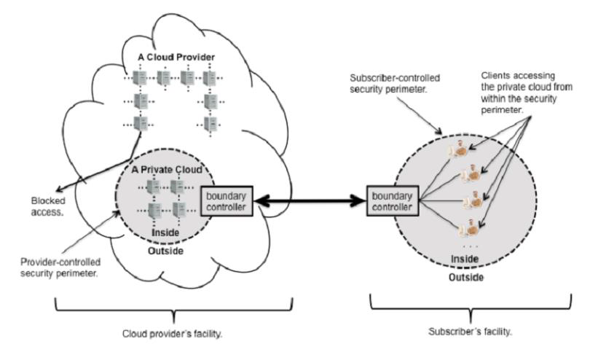

**Community Cloud**

* Cloud infrastructure is provisioned for exclusive use by a specific community of consumers from organizations that have shared concerns (e.g., mission, security requirements, policy, and compliance considerations). It may be owned, managed, and operated by one or more of the organizations in the community, a third party, or some combination of them, and it may exist on or off premises
* Examples of Community Cloud:

Google Apps for Government

Microsoft Government Community Cloud

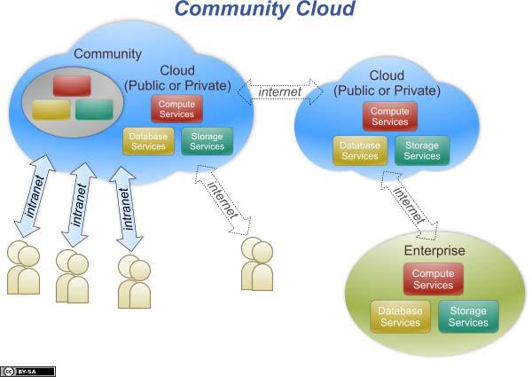

**On-site Community Cloud**

* Applies to community clouds implemented on the premises ofthe customers composing a community cloud
* Community cloud is made up of a set of participant organizations. Each participant organization may provide cloud services, consume cloud services, or both
* At least one organization must provide cloud services
* Each organization implements a security perimeter
* The participant organizations are connected via links between the boundary controllers that allow access through their security perimeters

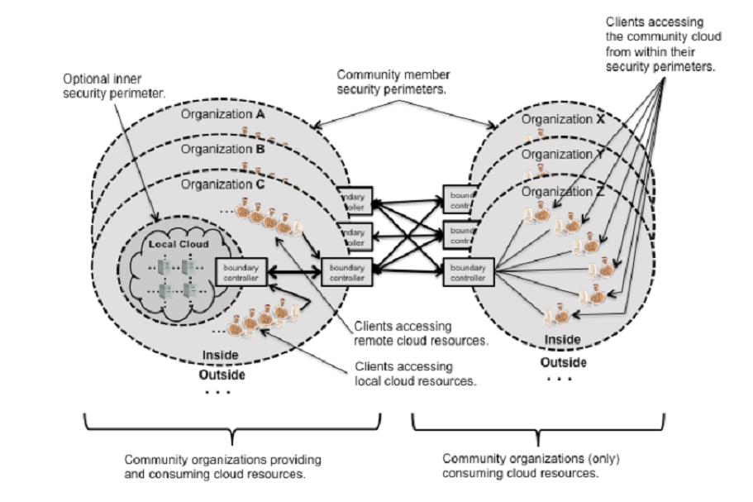

**Outsourced Community Cloud**

* Applies to community clouds where the server side isoutsourced to a hosting company.

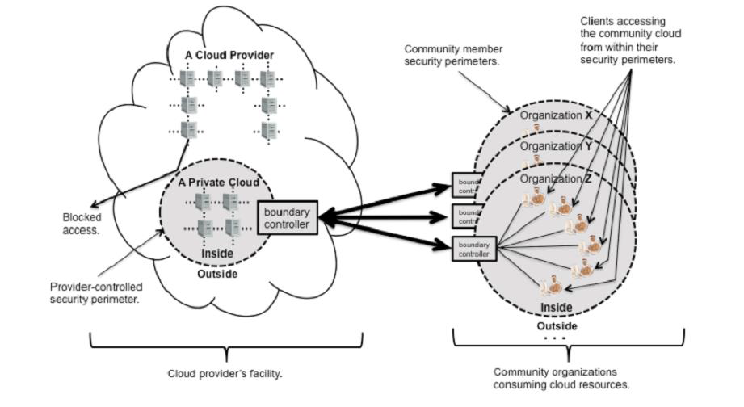

**Hybrid Cloud**

* The cloud infrastructure is a composition of two or more distinct cloud infrastructures (private, community, or public) that remain unique entities, but are bound together by standardized or proprietary technology that enables data and application portability
* Examples of Hybrid Cloud:
* –Windows Azure (capable of Hybrid Cloud)
* –VMware vCloud (Hybrid Cloud Services)

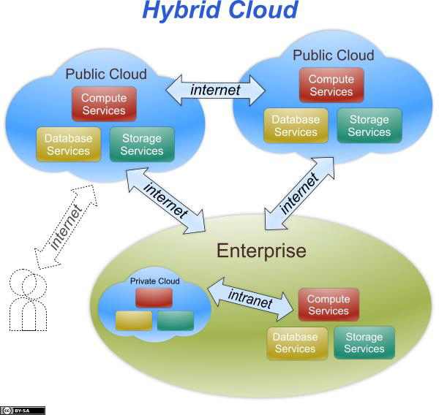

* A hybrid cloud is composed of two or more private, community, or public clouds.
* •They have significant variations in performance, reliability, and security properties depending upon the type of cloud chosen to build hybrid cloud.
* A hybrid cloud can be extremely complex
* •A hybrid cloud may change over time with constituent clouds joining and leaving

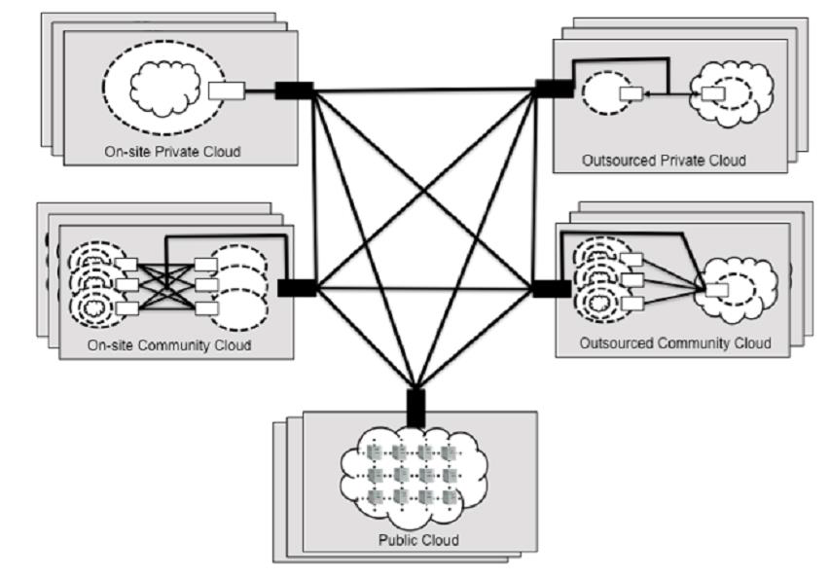

**Issues and challenges in Clouds**

* The following are some of the notable challenges associated with cloud computing, and although some of these may cause a slowdown when delivering more services in the cloud, most also can provide opportunities, if resolved with due care and attention in the planning stages.
* Security and Privacy
* Lack of Standards
* Continuously Evolving
* Compliance Concerns

Security and Privacy

* perhaps two of the more “hot button” issues surrounding cloud computing relate to storing and securing data, and monitoring the use of the cloud by the service providers.
* These issues are generally attributed to slowing the deployment of cloud services.
* These challenges can be addressed, for example, by storing the information internal to the organization, but allowing it to be used in the cloud.
* For this to occur, though, the security mechanisms between organization and the cloud need to be robust and a Hybrid cloud could support such a deployment.

Lack of Standards

* Clouds have documented interfaces; however, no standards are associated with these, and thus it is unlikely that most clouds will be interoperable.
* The Open Grid Forum is developing an Open Cloud Computing Interface to resolve this issue and the Open Cloud Consortium is working on cloud computing standards and practices.
* The findings of these groups will need to mature, but it is not known whether they will address the needs of the people deploying the services and the specific interfaces these services need.
* However, keeping up to date on the latest standards as they evolve will allow them to be leveraged, if applicable.

Continuously Evolving

* User requirements are continuously evolving, as are the requirements for interfaces, networking, and storage.
* This means that a “cloud,” especially a public one, does not remain static and is also continuously evolving

Compliance Concerns

* The Sarbanes-Oxley Act (SOX) in the US and Data Protection directives in the EU are just two among many compliance issues affecting cloud computing, based on the type of data and application for which the cloud is being used.
* The EU has a legislative backing for data protection across all member states, but in the US data protection is different and can vary from state to state.
* As with security and privacy mentioned previously, these typically result in Hybrid cloud deployment with one cloud storing the data internal to the organization.

Cloud Delivery Models: IaaS, PaaS, SaaS

(Service model)

# Infrastructure as a Service | IaaS:

IaaS provider provides the following services -

1. **Compute:** Computing as a Service includes virtual central processing units and virtual main memory for the Vms that is provisioned to the end- users.
2. **Storage:** IaaS provider provides back-end storage for storing files.
3. **Network:** Network as a Service (NaaS) provides networking components such as routers, switches, and bridges for the Vms.
4. **Load balancers:** It provides load balancing capability at the infrastructure layer.

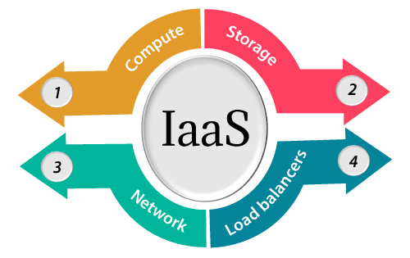

## **Advantages of IaaS cloud computing layer**

There are the following advantages of IaaS computing layer -

**1. Shared infrastructure**

IaaS allows multiple users to share the same physical infrastructure.

**2. Web access to the resources**

Iaas allows IT users to access resources over the internet.

**3. Pay-as-per-use model**

IaaS providers provide services based on the pay-as-per-use basis. The users are required to pay for what they have used.

**4. Focus on the core business**

IaaS providers focus on the organization's core business rather than on IT infrastructure.

**5. On-demand scalability**

On-demand scalability is one of the biggest advantages of IaaS. Using IaaS, users do not worry about to upgrade software and troubleshoot the issues related to hardware components.

## **Disadvantages of IaaS cloud computing layer**

**1. Security**

Security is one of the biggest issues in IaaS. Most of the IaaS providers are not able to provide 100% security.

**2. Maintenance & Upgrade**

Although IaaS service providers maintain the software, but they do not upgrade the software for some organizations.

**3. Interoperability issues**

It is difficult to migrate VM from one IaaS provider to the other, so the customers might face problem related to vendor lock-in.

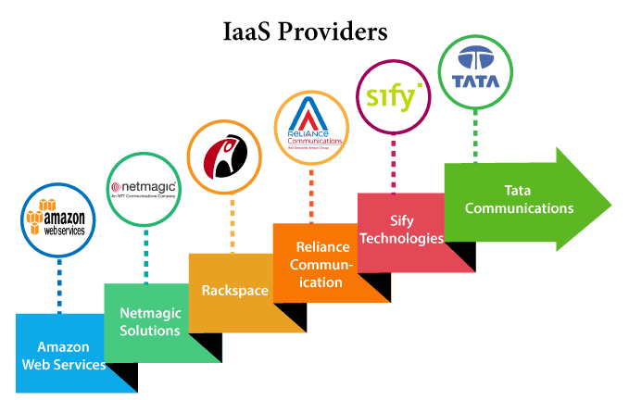

## **Layered Architecture of Cloud**

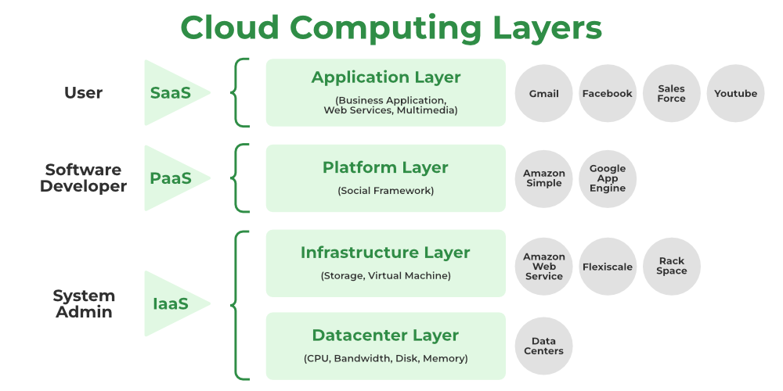

### Application Layer

1. The application layer, which is at the top of the stack, is where the actual cloud apps are located. Cloud applications, as opposed to traditional applications, can take advantage of the **automatic-scaling**functionality to gain greater performance, availability, and lower operational costs.
2. This layer consists of different Cloud Services which are used by cloud users. Users can access these applications according to their needs. Applications are divided into **Execution layers** and **Application layers**.
3. In order for an application to transfer data, the application layer determines whether communication partners are available. Whether enough cloud resources are accessible for the required communication is decided at the application layer. Applications must cooperate in order to communicate, and an application layer is in charge of this.
4. The application layer, in particular, is responsible for processing IP traffic handling protocols like Telnet and FTP. Other examples of application layer systems include web browsers, SNMP protocols, HTTP protocols, or HTTPS, which is HTTP’s successor protocol.

### Platform Layer

1. The operating system and application software make up this layer.
2. Users should be able to rely on the platform to provide them with **Scalability, Dependability, and Security Protection**which gives users a space to create their apps, test operational processes, and keep track of execution outcomes and performance. SaaS application implementation’s application layer foundation.
3. The objective of this layer is to deploy applications directly on virtual machines.
4. Operating systems and application frameworks make up the platform layer, which is built on top of the infrastructure layer. The platform layer’s goal is to lessen the difficulty of deploying programmers directly into VM containers.
5. By way of illustration, Google App Engine functions at the platform layer to provide API support for implementing storage, databases, and business logic of ordinary web apps.

### Infrastructure Layer

1. It is a layer of virtualization where physical resources are divided into a collection of virtual resources using virtualization technologies like Xen, KVM, and VMware.
2. **This layer serves as the Central Hub of the Cloud Environment**, where resources are constantly added utilizing a variety of virtualization techniques.
3. A base upon which to create the platform layer. constructed using the virtualized network, storage, and computing resources. Give users the flexibility they want.
4. Automated resource provisioningis made possible by virtualization**,** which also improves infrastructure management.
5. The infrastructure layer sometimes referred to as the virtualization layer, partitions the physical resources using virtualization technologies like**Xen, KVM, Hyper-V, and VMware** to create a pool of compute and storage resources.
6. The infrastructure layer is crucial to cloud computing since virtualization technologies are the only ones that can provide many vital capabilities, like dynamic resource assignment.

### Datacenter Layer

* In a cloud environment,this layer is responsible for **Managing Physical Resources** such as servers, switches, routers, power supplies, and cooling systems.
* Providing end users with services requires all resources to be available and managed in data centers.
* Physical servers connect through high-speed devices such as routers and switches to the data center.
* In software application designs, the division of business logic from the persistent data it manipulates is well-established. This is due to the fact that the same data cannot be incorporated into a single application because it can be used in numerous ways to support numerous use cases. The requirement for this data to become a service has arisen with the introduction of microservices.
* A single database used by many microservices creates a very close coupling. As a result, it is hard to deploy new or emerging services separately if such services need database modifications that may have an impact on other services. A data layer containing many databases, each serving a single microservice or perhaps a few closely related microservices, is needed to break complex service interdependencies.